The code : nslookup

Set type=mx

Ibm.com

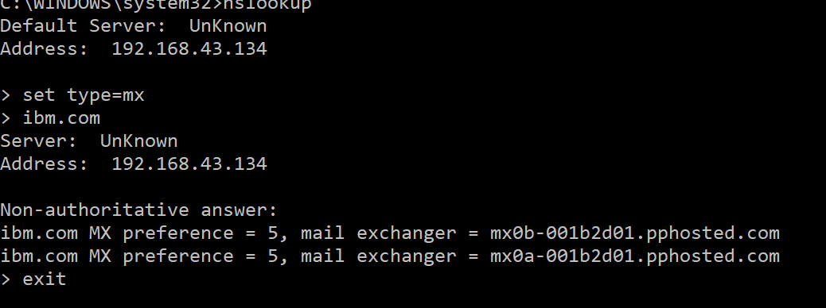

The code : nslookup

Set type=mx

Wipro.com

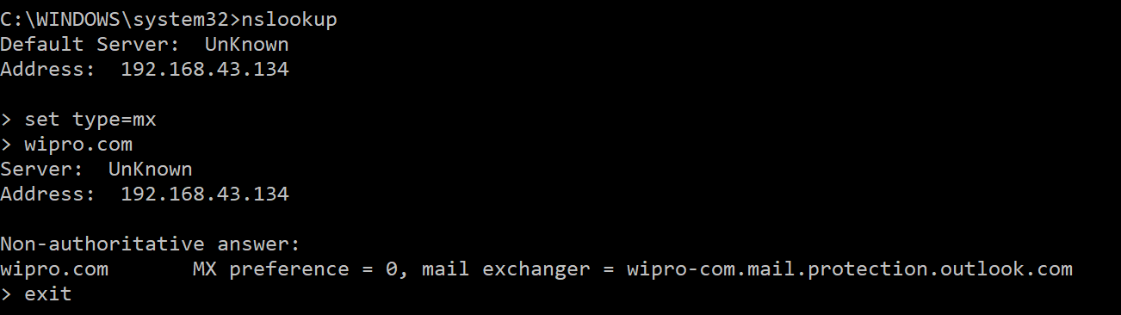

The code : nmap 203.163.246.23

